Week 4: Data & Engagement Deliverable
Project Title: [The Sauce]
Group Members: [Jonathan Le, Densel Aquino]
Current Sprint Status: [On Track / Delayed]

1. Technical Database: SQLite
This week, the app must transition from local-only data to a live cloud backend (using public tables or service roles as planned):
- SQLite Database Connection: Is your app successfully connecting to SQLite?
- CRUD Operations: Are you successfully Reading from and Writing to a SQLite table? (e.g., fetching a list of items or posting a new map marker).

2. Feature Integration: Notifications
Per the project guidelines, your app must now engage the user:
- Notification Type: Did you implement Local notifications (triggered by app logic) or Push notifications? Local notifications
- Trigger Logic: Describe the specific event that triggers the notification (e.g., "A notification is sent 5 seconds after a user successfully saves a new Map marker to the cloud"). At exactly 8:00PM, a notification is sent to the user, saying it’s dinner time, and asking if they would like to eat.
- Permissions: Does the app properly request notification permissions from the user on the first launch? (Yes/No)

3. GitHub Workflow Audit: Integration Focus
As the codebase grows more complex with API keys and secrets, focus on security and coordination:
- Pull Request (PR) Links: Provide links to the two most significant merges this week:
  - feat/supabase-integration: [PR Link]
  - feat/notifications: [PR Link]
- Peer Review Quality: List one specific piece of feedback a teammate gave during a PR review that improved the code.
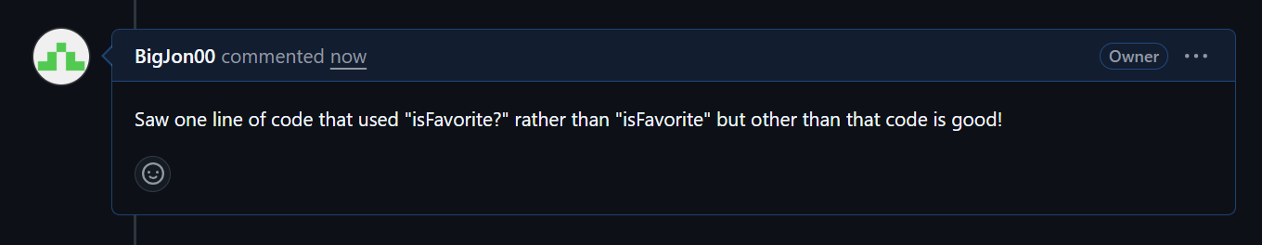

4. Polishing the "Dynamic Route"
- Real-Time Data: Is your Dynamic Route Landing Page (Details/[id]) now fetching its specific data directly using the ID from the Database? (Yes/No)

5. Milestone 4 Goals (End of Week 4)
By the end of this week, we have successfully:
- [ ] Connected the app to a live SQLite backend.
- [✓] Triggered a functional Notification based on a user action.

